**Searching with UI problems and feedback:**

* When I search for “Nike react phantom run flyknit 2”, It gives me 2 products. Though the products are the same just they are different in color. Also, I can select the color by going inside the product details and clicking the product. So, there is no need to show two products as the search result.

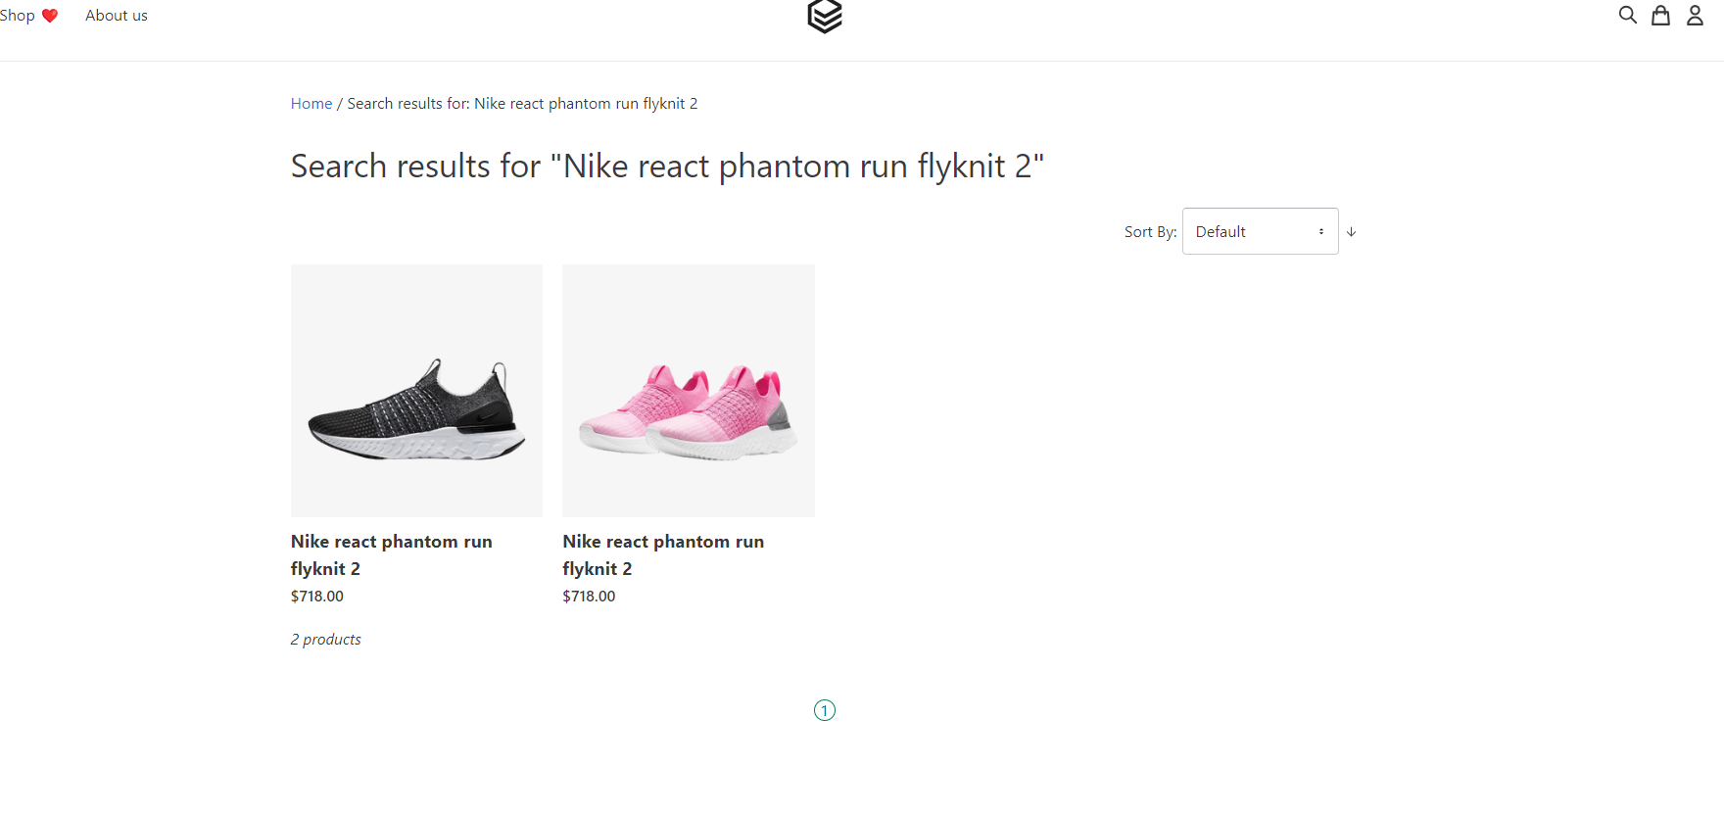

Fig-1: Search result

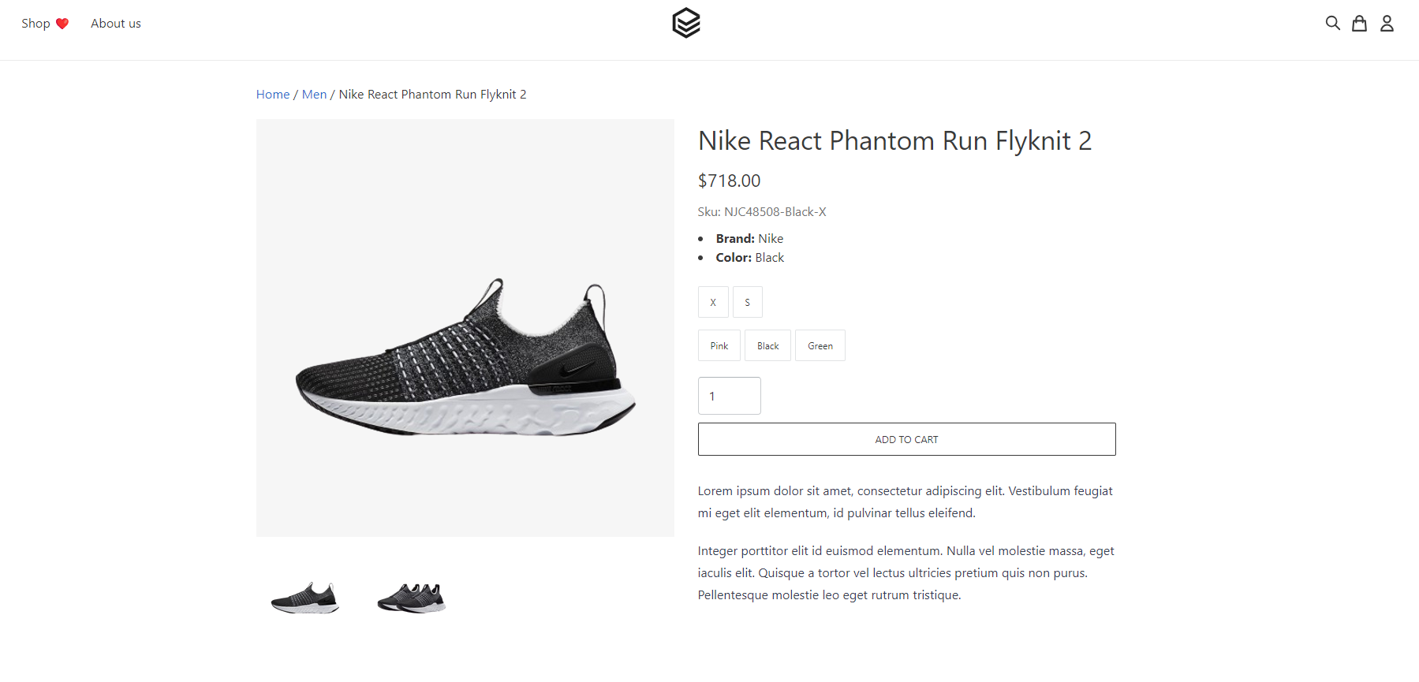

Fig-2: Inside the product

* Another disparity is that there are green products also that can be selected from inside the product details. So, if the search result stays like this then green should be also added to the search result.
* When entering the product detail page, If we notice the “sku” we can see the x-size product is selected by default. But there is no indication in the UI that X-size product is selected. That can create some sort of confusion.

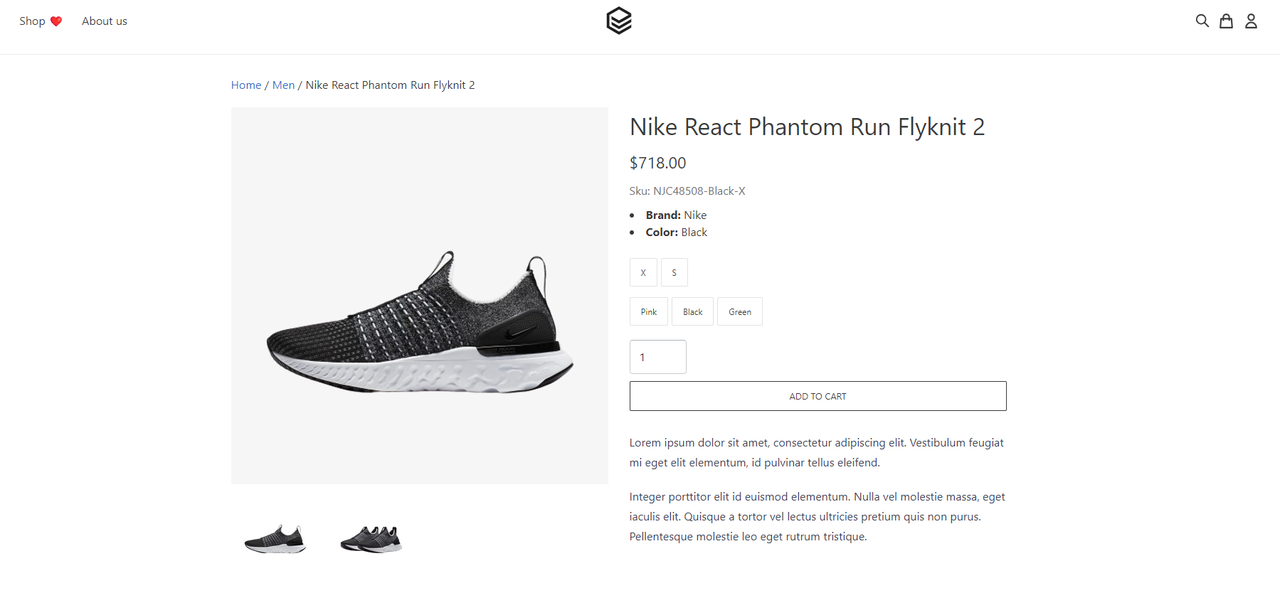

Fig-3: inside product details

* There is another defect when we select s size green shoe. The “sku” does not change. It states as x size black. But if I select x size green shoe then the “sku” change. So even if the S-size green shoe is not in stock then it should give some message or warning.

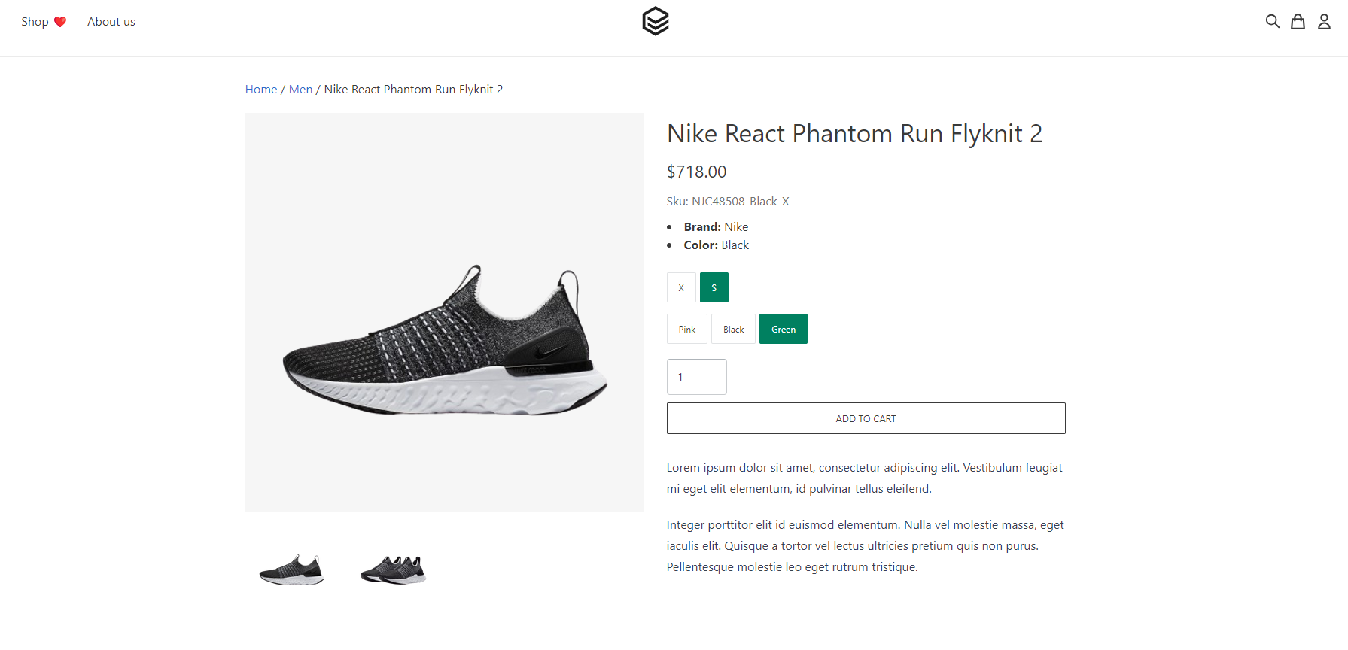

Fig-3: SKU does not changes

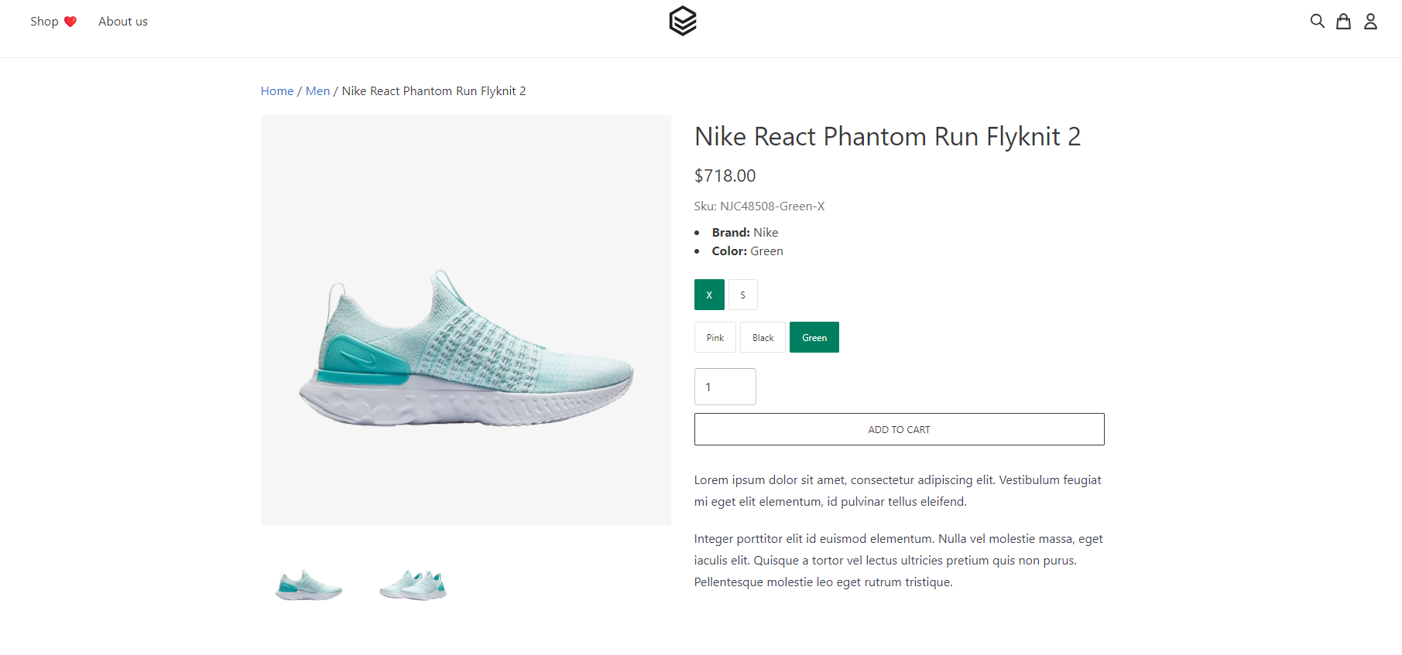

Fig-5: SKU changes

* If we select size S, somehow automatically the color of the product becomes pink even if we haven’t selected any color yet.

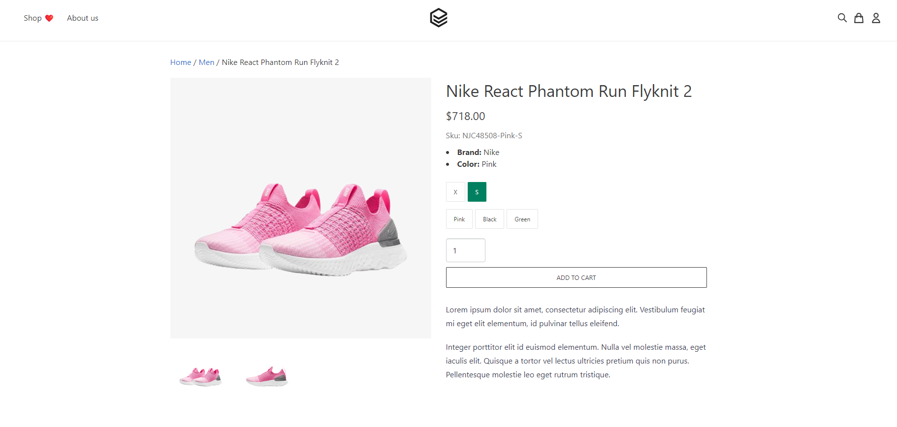

Fig-6: color changes

* When the product is added to the cart, in the cart logo it shows 2(the quantity of the product). But it should show how many types of products are added to the cart.

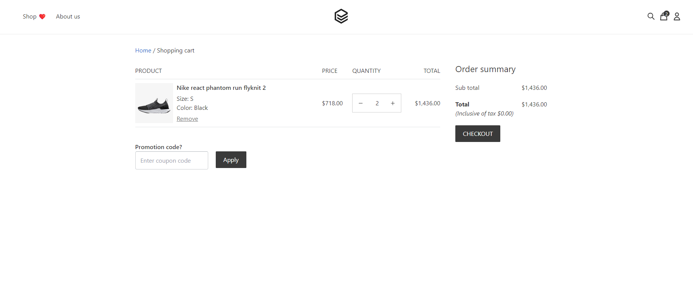

Fig-7: cart

**Searching and adding to cart with API**

In the process of API testing, I have done 4 get requests and 1 post request.

When verifying the cart with API, I found a disparity. I have added S-sized black shoes. But it shows X-sized black shoes.

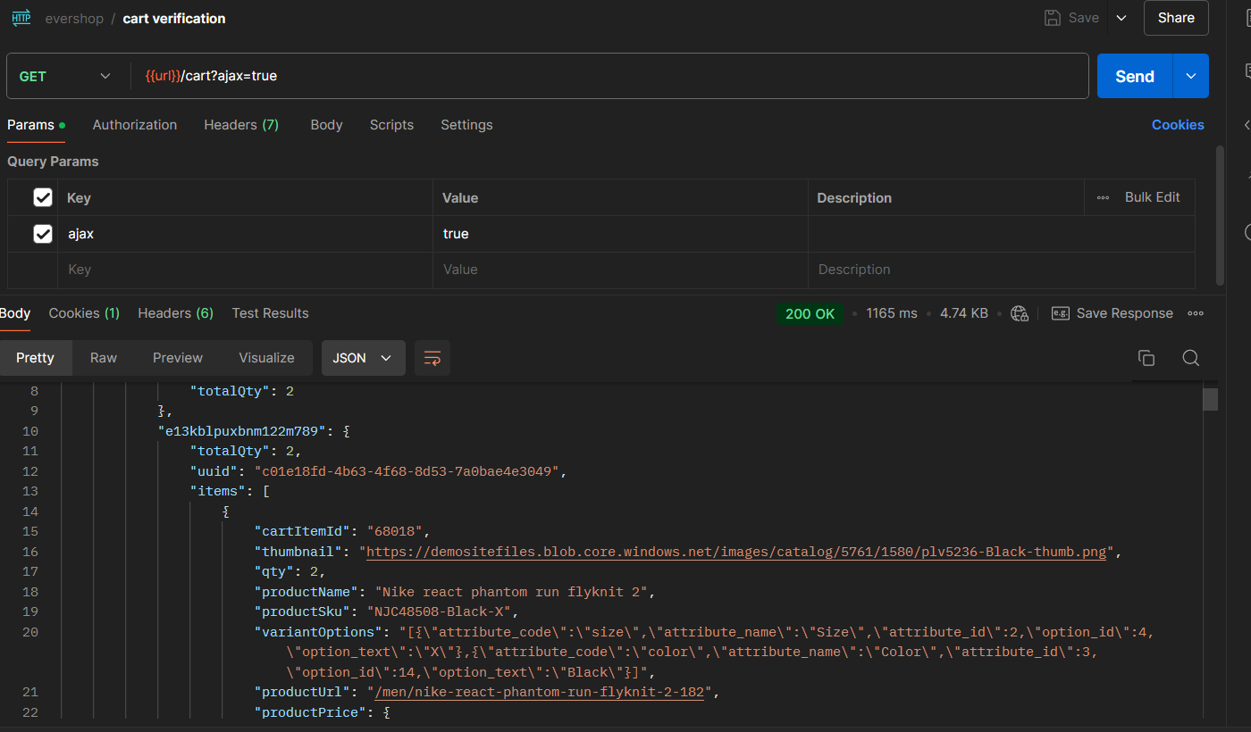

Fig-8: Postman

The values that API returns are not well formatted as well. These things need to be looked into.